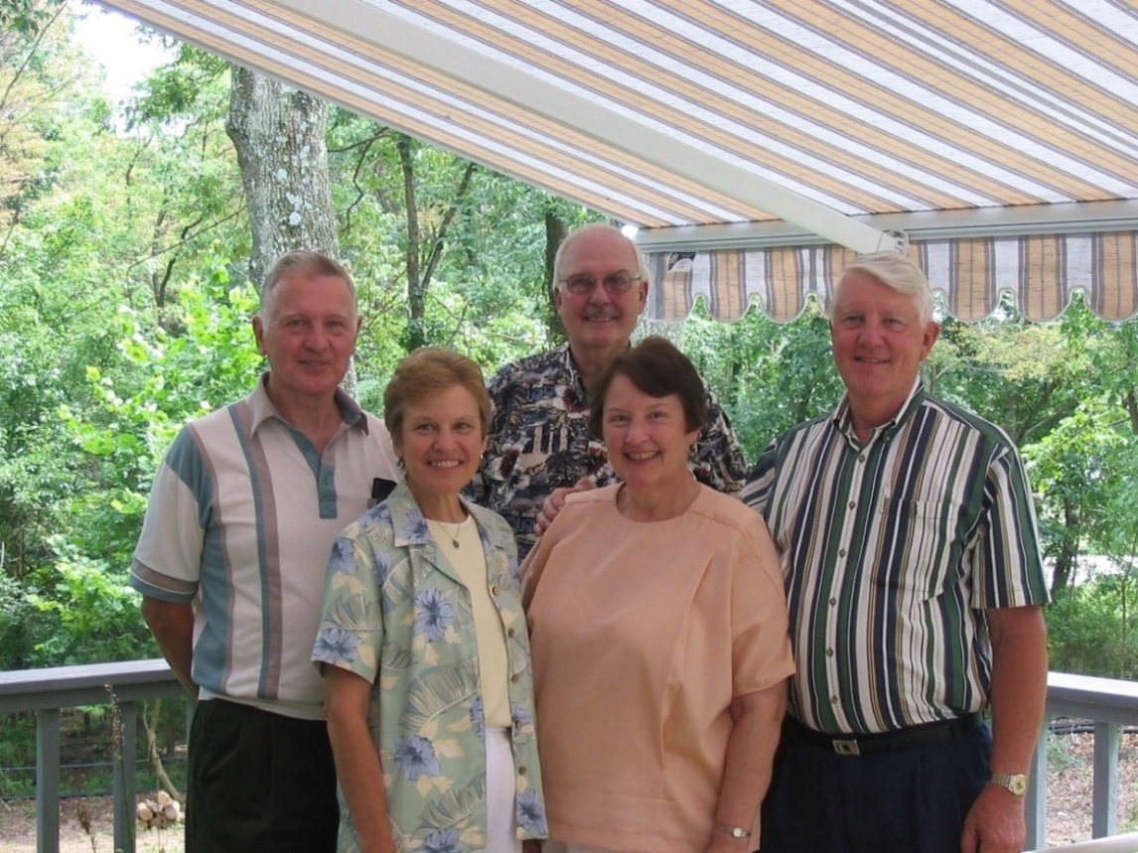

Mark List, Brenda Huffines, Ronald List, Dotty Jo List Raasch, David List - 30 July 2004

**Ronald List and Family**

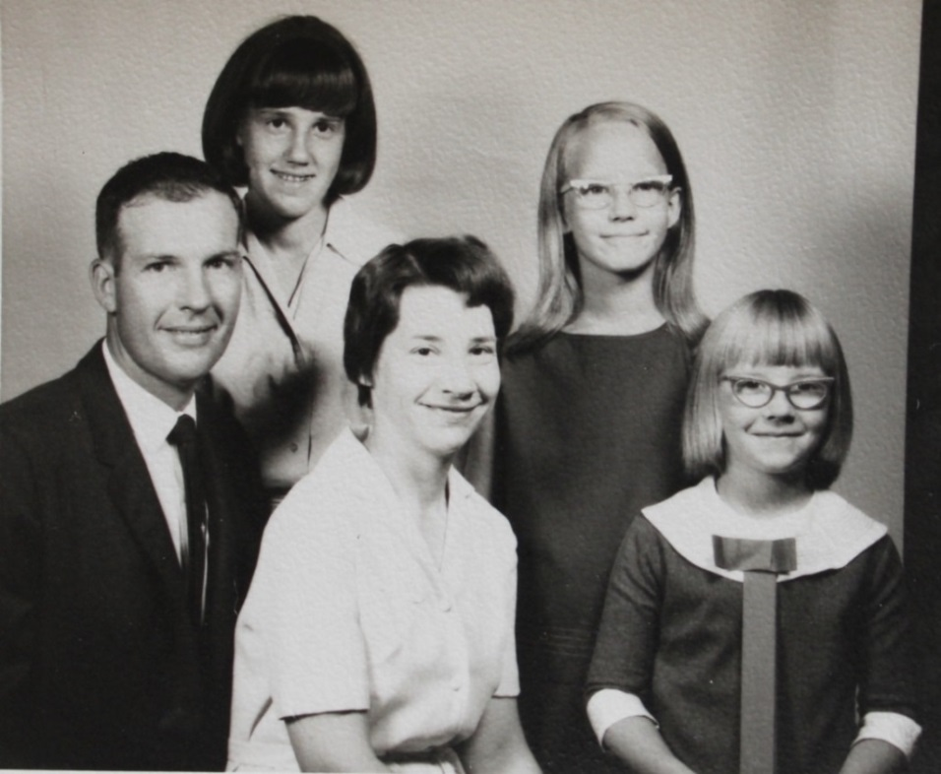

(l-r) Ronald, Susan, Jo Ann, Judith and Marilyn List about – about 1966.